SYSTEEM EN REGELTECHNIEK VRAGEN EN ANTWOORDEN

**What does a control system consist of?**

It consists of subsystems and processes(plants) that give a desired output with desired performance from an input

**Why do we build control systems?**

Power amplification, Remote Control, Convenience of input form, Compensation for disturbances

**What is power amplificiation or power gain?**

Power amplification or power gain is when we want to amplify the power used at the input for a greater power at the output

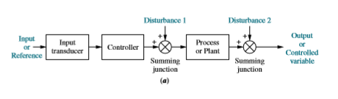

**What is an input transducer?**

An input transducer transforms the input into a form which can be used by the controller

**What is the function of a controller?**

A controller drives a process or plant

**What are the input and output also referred to as?**

The input is sometimes called the reference and the output the controlled variable

**What are the summing junctions for?**

They are a way to add other signals such as disturbances to the controller and process outputs

**What is the main downfall of an open loop system?**

It cannot compensate for disturbances added to the driving signal of the controller or output by way of the summing junctions. No adjustment for signal corruption.

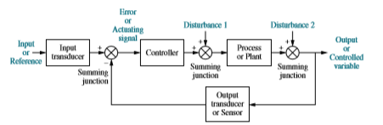

**Describe the way a closed system work?**

You have the input signal which goes to the input transducer which converts it into a forma usable by the controller. The controller sends the necessary signal to the process or plant for the desired output. The output signals response goes by way of output transducer sent via a feedback loop to the summing junction of the controller and gets subtracted from the input signal. The algebraic difference of these two signals is called the error or actuating signal. The disturbances are added to the driving signal by way of the summing junctions.

**What are the two ways by which we measure a systems performance?**

The transient response and the steady state error

**What types of control systems do we know?**

Open and closed loop systems

**What are the differences between open and closed loop systems?**

Open loop systems are easier to make and cheaper but they do not monitor or correct the output for disturbances

**What is the purpose of control system analysis and design?**

1. Producing the desired transient response
2. Reducing steady state errors
3. Achieving stability

**What is the purpose of transient response?**

It effects the speed of the system and influences human patience and comfort plus mechanical stress

**What is the purpose of steady state response?**

It is a measurement of the accuracy of the system. It indicates how well the system is able to match the output with the desired response

**How do we design a control system?**

**Step 1**

Determine a physical system and specifications from requirements.

**Step 2**

Draw a functional block diagram.

**Step 3**

Represent the physical system as a schematic.

**Step 4**

Use the schematic to obtain a mathematical model, such as a block diagram.

**Step 5**

Reduce the block diagram.

**Step 6**

Analyze and design the system to meet specified requirements and specifications that include stability, transient response, and steady-state performance.

**What is considered to be the total response of a system?**

The sum of the natural response and the forced response

**What is the difference between the forced response and the natural response of a system?**

The natural response is the way that a system acquires and dissipates energy and is dependent solely on the system and not the input. Contrary to the natural response, the forced response **is**  dependent on the input.

**What is referred to as instability?**

The natural response must eventually equal zero or the oscillate. If it does not eventually equal zero or oscillate then the system is no longer controlled.

**What are the consequences of system instability?**

The instability could ultimately lead to self-destruction

**How can self-destruction of the system be prevented?**

By implementing limit stops on the system(e.g. preventing elevator from flying through the sealing)

**What is the difference between control system analysis and design?**

**Analysis** is the means by which **system performance** is determined(e.g. transient response and steady state error meet desired specifications) and **design** is the process by which **system performance** is **created or changed**(e.g. if steady state error and transient response don’t match desired specifications then we change the parameters or add components)

**Why is transient response important?**

It can be about **comfort** (e.g. elevator and transient response makes people impatient if it osciallates about the desired floor for too long) and also **performance** (e.g. the read head of a HDD that moves from one track to another on the disk)

**What is the steady state response?**

It resembles the input and is what remains after the transient response is equal to zero(e.g. elevator needs to be leveled to the correct floor in order for passengers to get off)

**Why is the controller a computer in controlled systems?**

In many case the controller/compensator is computer and the benefit is that many loops can be controlled by one computer by way of time sharing. Another benefit is that adjustments of compensator parameters can be done by way of software instead of hardware